Setup SSH

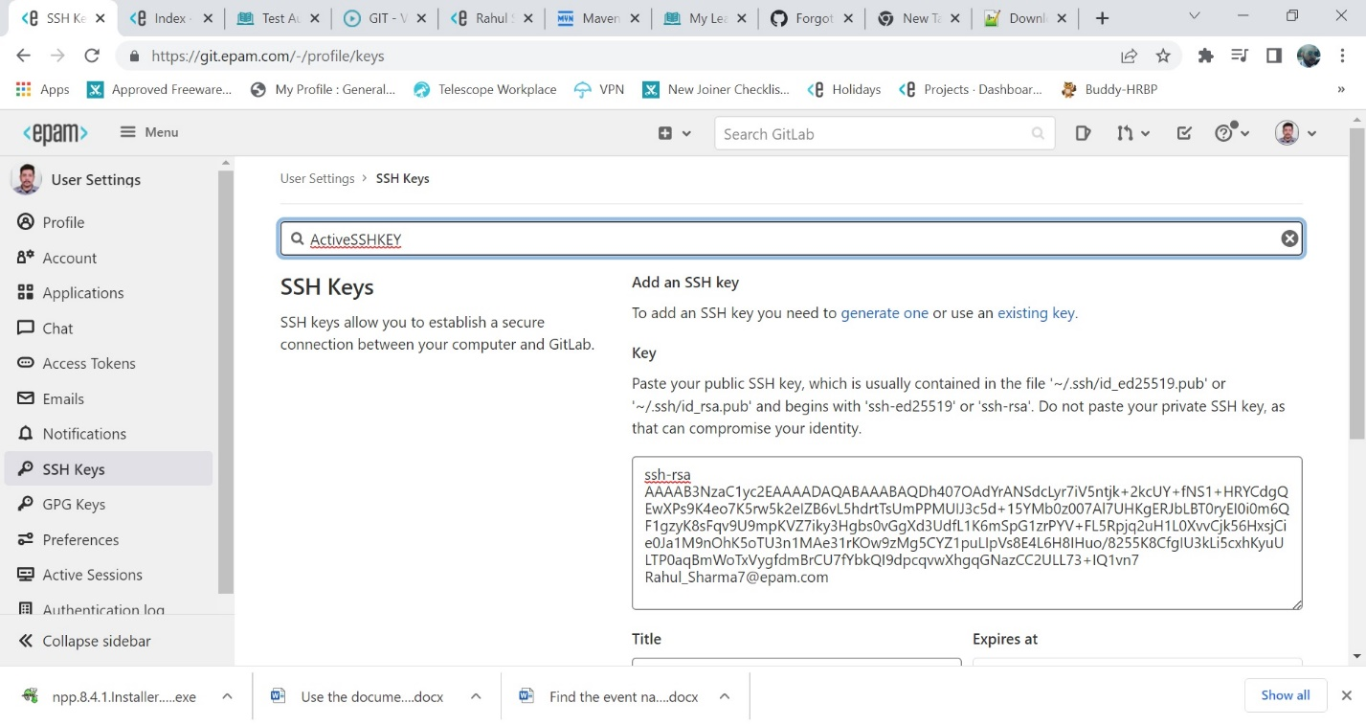

Clone using SSHKey

Pushed two commits in remote master

Cut out new branch test from master

Two commits to test

Created and pushed to new remote branch test

Merge test to master using Merge Request

Pulled Remote master to local master for sync

Two more commits to test

Pushed two new commits to remote test

3rd commit to master

Pushed third commit to remote master

Mergre test to master with Merge request

Git pull to local master to sync remote master

Two new commits to test

One new commit to master

Rebase test with master

Pushing rebased test to remote test

Rebased remote test with remote master

Merging rebased remote test with remote master with merge request

Git pull on local master to sync remote master with changes from rebased test merge to master

Two new commits to test

Pushed to remote test

Pushed cherrypicked commit in master to remote master

Reset bad commit in test local

Reverting on remote

Pushing revert commit to remote test